**Activity 01**

Making the flowchart

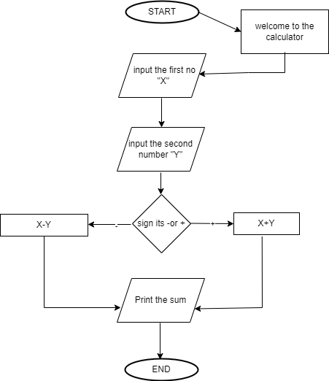

Making the pseudocode

BEGIN

    PRINT "S=12"

    INPUT

       Number P

  REPEAT UNTIL

        S=0

    IF P is even

     PRINT"P=P+1"

    ELSE

     PRINT"P is prime"

     PRINT

       P<S

    ELSE

     PRINT "P=P+1"

  WHILE

       P<S

     PRINT"S=S-P"

    ELSE

      S=S-1

    IF

      S=S-1

      PRINT "S=0"

      OUTPUT P

    ELSE

      P=P+1

END

TASK 02

01..

FLOWCHART

PSEUDOCODE

BEGIN

  INPUT

    First Number {NUM 1}

    Second Number {NUM 2}

  REPEAT UNTIL

    IF NUM 1 > NUM 2

    PRINT " NUM 1 is the largest"

    ELSE

    PRINT "NUM 2 is the largest"

  SET

    NUM 1 equals to NUM 2

    IF NUM 1 = NUM 2

    PRINT " NUM 1 is the largest"

    ELSE

    PRINT " NUM 2 is the largest"

END

02..

FLOWCHART

PSEUDOCODE

BEGIN

 Download the social media

  INPUT

     Email,Password and Unique user name

  REPEAT UNTIL

  INPUT

     Unique user name

    IF

     username accepted

     PRINT "ACCEPTED"

     ELSE " CHOOSE ANOTHER NAME"

  INPUT

     Password

    IF

     Password is strong

     PRINT "STRONG"

     ELSE

     PRINT "WEAK"

  INPUT

     Email

    IF

     Email is correct

     PRINT " THE CODE HAS IS VERIFIED"

     ELSE

     PRINT "TRY AGAIN OR RESEND"

  OUTPUT

     Logged to the media as code is verified succefully

END